

**User Agreement Guide – Alpha 1.0**

JNA Radio Services

Table of Contents

1. Introduction 3

1.1 What is InterRadio? 3

1.2 System Overview 3

2. System Features 3

2.1 Internet Radio 3

2.2 Playback Toolbar 3

2.3 Genre Toolbar 3

# Introduction

## 1.1 What is InterRadio?

InterRadio is an internet radio application, currently able to stream over 80 radio stations from Europe, Oceania, North America, South America, and Africa. Stations provided by InterRadio are broken into four “Genres”: Sports, Music, News, and General. The application allows the user to select what “Genre” of radio they would like to listen to, and filters available stations accordingly. A playback toolbar allows users to operate the audio of the application.

## 1.2 System Overview

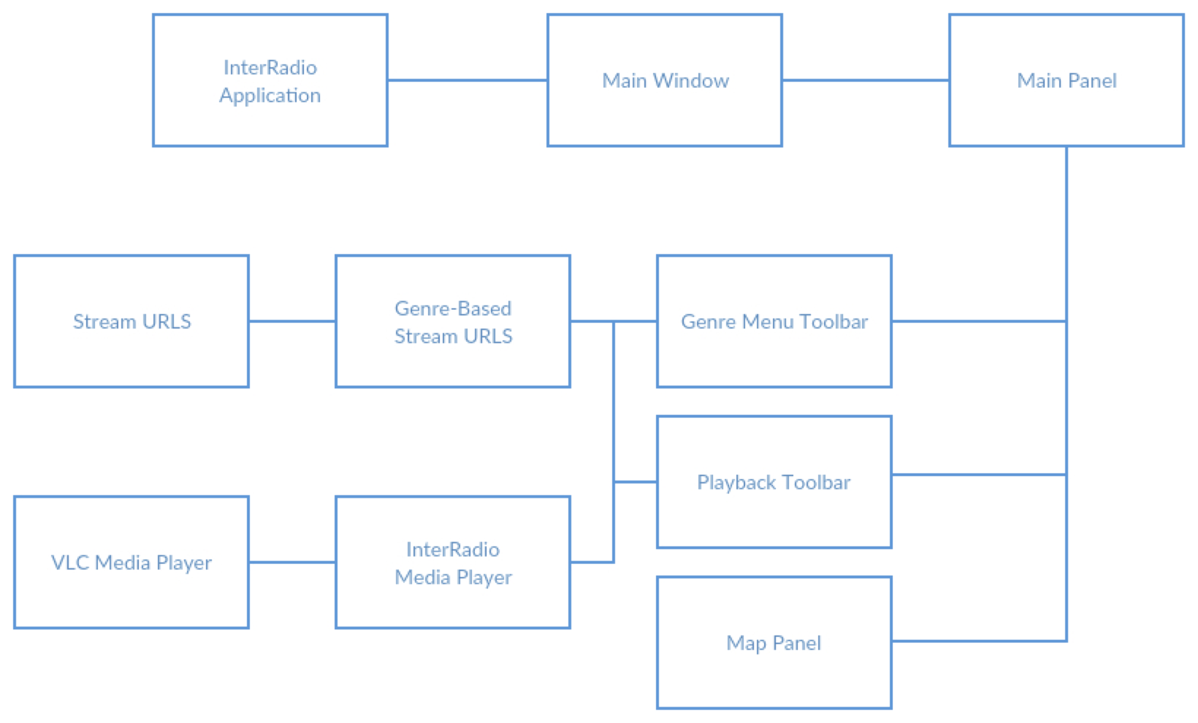

*Table 1.1: Application Structure*

Using IntelliJ IDEA, InterRadio is a java-based application. As shown above, It uses stream URLS collected from different radio stations and VLC Media Player files to create the foundations of the application. The InterRadio Media Player is a media player that works on both Windows and Macintosh OS X by incorporating both sets of files into one player.

# System Features

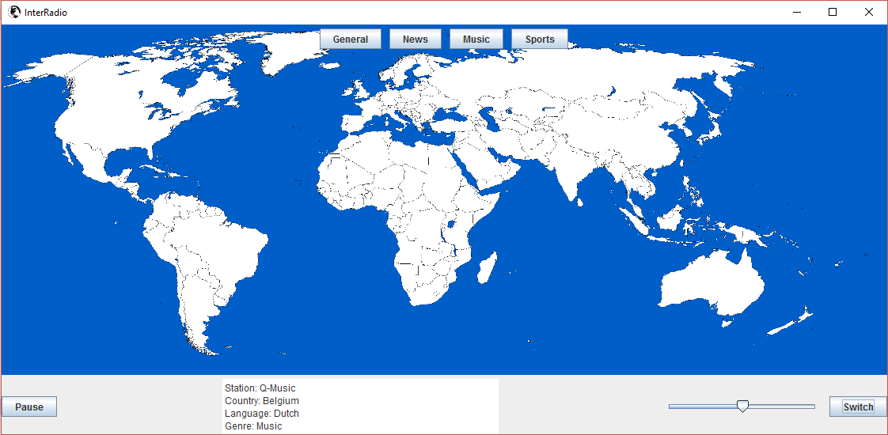

## 2.1 Internet Radio

InterRadio uses internet streams from national and regional radio stations from different countries. Using stream URLs, InterRadio provides live broadcasts from 100+ radio stations. These stream URLs are then divided into genres for the user to select (See 2.3 Genre Toolbar). For the app to receive radio, users must be connected to the internet.

## 2.2 Playback Toolbar

The playback toolbar allows the user to control the audio playback of the application. This toolbar is situated at the bottom of the window and contains: a slider to adjust the volume of the radio, a button to play and pause the radio, a button to switch the audio source, and a display to show information about the station and song playing (when available). The “Switch” button starts the radio station, and cycles through stations in the currently selected “Genre”. On startup, all stations are available to be cycled through, until a user selects a specific “Genre”.

## 2.3 Genre Toolbar

The genre toolbar allows the user to choose which “Genre” of radio they would like to have access to, and filters all available stations accordingly. Users can select a single “Genre”, multiple “Genres”, or all “Genres” to be displayed and to be made ready to play. Additionally, stations that fall into more than one “Genre” will be filtered when any of its respective “Genres” have been selected.